THE NUTS AND BOLTS OF PHILOSOPHY
Since you picked up this, you must be at least a little curious about philosophy. As life gets more complicated, it gets more confusing. Every day, more thorny problems—politics, the environment, religion, education, technology, family, the community—clamber for attention. Learning some philosophy can help you deal with life's difficulties by taking you away from them for a while, and by leading you back into them with new ideas about what it's all about.
Philosophy doesn't have to be hard to understand. It does help if you have some basic questions and ideas in mind as you look into a new philosophy. How do the new ideas compare with the ones you already think about? What problems do the new ideas have that the old ones don't? What problems does the new thinking manage to avoid?
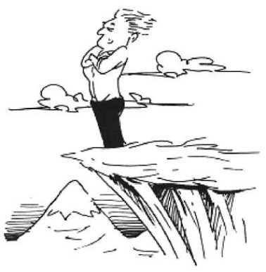
The first part of this note thinks about philosophy in terms of three basic issues: being, knowing, and acting. Philosophy continually asks questions about these issues: What exists? Is existence organized? What counts as knowledge? How do we know things? How should we act? Do we act according to a human nature? Keeping these questions in mind makes it easier to make sense of particular philosophical ideas and of philosophy in general.
The Big Picture
In this discussion you would understand
- Why philosophers philosophize
- What philosophy is
- Why There are so many "isms"
- What the main branches of philosophy arc and how they relate to one another.
Philosophers think about everything. And they tend to take a broader view of everything than most other people. They look at things as if from farther away, to see how they all fit together. This note, in talking about philosophy as a whole, paints a big picture of lots of big pictures.
To some, philosophy may seem like a silly or irrelevant waste of time, a distraction from the obvious, important (though often boring) things that everybody has to deal with—work, school, relationships, bills. There is plenty of traditional support for this view. Legend has it that the ancient Greek philosopher, Thales, was out walking one night and was so intent on contemplating the stars that he didn't see where he was going and fell into a well. Focusing on far-away, irrelevant things, philosophers can sometimes lose sight of the here and now.
Why Ask Why?
Let's face it: Philosophy doesn't always give us anything we can take to the bank. Could it be that philosophy is basically useless?
The fact is, philosophy is unavoidable. Even if you think you don't already have a philosophy, you actually do. Like everybody else, you live your life according to ideas and assumptions about what the world is like that you picked up along the way.
If you're not as satisfied with the way things are as you think you should be-and who is?-you might want to rethink your ideas about what reality is all about. This rethinking is precisely what philosophers have been doing over the centuries.
For example, people used to think that, whenever anything bad happened, the gods were angry. They thought their gods wanted them to show their loyalty and obedience by making big sacrifices, even of their own children! Gradually, people with a philosophical turn of mind began questioning this assumption. Maybe the gods would be just as happy if we let our children live? This required a whole rethinking of what life, God, and human nature are all about-just the kind of rethinking philosophers do. Today, of course, the incidence of human sacrifice has been greatly reduced. Thank a philosopher.
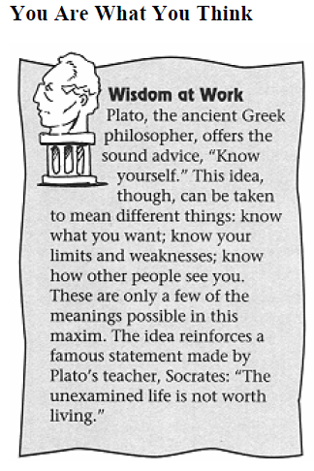
You Are What You Think
People have a lot of great ideas, and stupid ideas, about reality. If you can sort out these ideas and make sense of them, it can help you understand your own reality. This note is intended to help you do just that. It will help you recognize and understand philosophical ideas when you come across them, and see which ones make sense for you and which ones belong on the scrap heap of history.
As you read this note, you'll learn that you think a lot of things already. Lots of the thinking that important philosophers have done is stuff that may have already occurred to you. Seeing where your ideas come from and how others have used them may help you make better sense of who you are and what your life is about.
Even though there is a lot philosophy can't do, such as give you big muscles like Auguste Rodin's statue, The Thinker, it can do some pretty important things. In particular, it can help you think about thinking. Everybody does it, and it's especially nice to be able to do it well, both for its own sake and for the practical benefits thinking can yield. To clarify your thinking about thinking, this note shows how philosophers throughout history have tried to shed light on the big, deep questions, and suggests ways you can apply some of their answers to your life.

Big Names in the Ancient Game of Philosophy
If you’re into philosophy, it’s important to become acquainted with some of the early founding philosophers. This list contains the big names and big thinkers of ancient times:
- Pre-socratics: Anaximines, Anaxamander, Anaxagoras. Strange and famous names. Among the earliest philosophers on record. Costarring such luminaries as Thales, who believed that everything is made of water, once almost drowned, and got rich from getting a corner on the olive oil market. The Presocratics did speculative protoscience. Of course, they didn’t know they were Presocratics. But we do.
- Socrates: Did philosophy using The Socratic Method (duh). Hit the streets in search of wisdom. Executed by popular demand. Taught Plato.
- Plato: Hung around with Socrates. Wrote dialogues featuring his teacher. Maybe the most famous philosopher of all time. Taught the other contender for this accolade, Aristotle.
- Aristotle: Student of Plato. Codified logic. Said everyone seeks happiness. Taught Alexander the Great. Plato emphasized the next world; Aristotle concentrated on this one.
- The Stoics: Seneca, Epictetus, and Marcus Aurelius were the best known of the Roman Stoics. Main advice for handling any difficult thing in life: Put it in perspective and get over it.
Are you an idealist?
A realist ?
A pragmatist?
An existentialist?
Do you think about things rationally? Empirically? Intuitively?
Is your behavior directed by will? By other people?
Is there more to reality than what we can see and measure?
Studding this subject will help you understand what these questions mean and why they are important.
A Slice of Life.
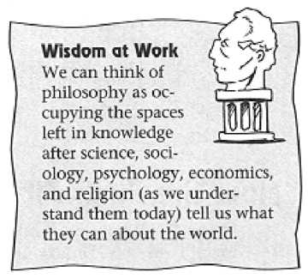
People engage in philosophy when they think about life and everything in it. The word philosophy, meaning “love of wisdom,” comes from ancient Greece, where people who liked thinking about life started calling themselves philosophers. Of course, “life” doesn't narrow things down very much. In ancient times and for centuries afterward, philosophy had an extremely wide scope, encompassing subjects we have since separated from philosophy, such as science, math, theology, psychology, sociology, and economics.
The ancient Greeks did not distinguish these fields from philosophy. As philosophers, they practiced them all-not, of course, in the same ways that a modern scientist studies science or a modern economist studies economics. These fields have changed and developed out of philosophy.
Philosophy still applies, however, to all of these fields. It is possible to study philosophy of science, or philosophy of religion, for example. Questions and problems that we call philosophical lie at the heart of all these subjects. Yet even after all of these fields have branched off from philosophy, there are still central issues and ways of thinking that are of particular interest to philosophers. To be more specific, philosophy tends to be concerned with broad, fundamental ideas about knowledge, cosmic reality, human nature, and society. And it is also, for better or worse, concerned with words.
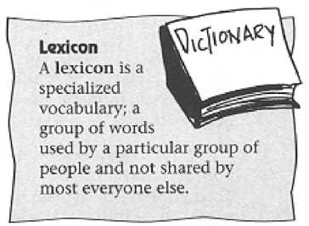
Is You Ism or Is You Ain't My Philosophy?
Philosophers can be hard to understand. That's because they often use words that sound like total gobbledygook to people who aren't philosophers. They have, in other words, a highly developed lexicon. A lexicon is a body of special words (jargon) used by a particular group of people—in this case, philosophers.
The philosophical lexicon is big because philosophy has dozens of different subdivisions and categories, and every category has a gazillion different movements, or isms. An ism is a system of belief, or a way of thinking that sees certain ideas as true or important while, inevitably, leaving other ideas out.
Philosophy still applies, however, to all of these fields. It is possible to study philosophy of science, or philosophy of religion, for example. Questions and problems that we call philosophical lie at the heart of all these subjects. Yet even after all of these fields have branched off from philosophy, there are still central issues and ways of thinking that are of particular interest to philosophers. To be more specific, philosophy tends to be concerned with broad, fundamental ideas about knowledge, cosmic reality, human nature, and society. And it is also, for better or worse, concerned with words.
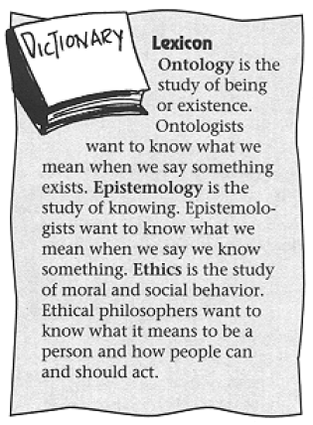
Grammatically speaking, isms are formed by turning a noun or adjective into a verb, then turning that verb back into a noun. For example, if you see knowledge as structural, and go on to structuralize knowledge, which means you subscribe to structuralism. If you believe Mickey Mouse holds the answer to life's deepest questions, and you Mickeyize your understanding of life, you believe in Mickeyism. Some popular isms within philosophy include sophism, skepticism, stoicism, scholasticism, mysticism, taoism, empiricism, rationalism, idealism, naturalism, materialism, pragmatism, existentialism, and anti-disestablishmen- tarianism, to name a few. And that doesn't include all the isms named after people (like Freudianism) and periods of time (like early post-modernism). They have to invent a new ism for every point of view-and there are lots of points of view.
What's more, philosophers have developed subdivisions within philosophy to deal with the deep questions they like to ask. The main subdivisions have to do with being, knowing, and acting. Philosophers call these subdivisions ontology (the study of being, or existence), epistemology (the study of knowing), and ethics (the study of how to act as a person). The next three chapters will look at each of these subdivisions in turn. The chapters after that explore specific philosophies-the isms and the people who invented them.

How the Parts Fit Together
Even though you can think about these three different subjects separately, they all work together to make philosophy what it is. Different philosophies place different emphases on these subjects. Most philosophers do their work by expanding on what they already think they know. Different philosophers identify different places to start-different foundational ideas on which to build their thinking. For example, Plato's epistemology and ethics are derived from his ontology. This simply means that his ideas about knowing and about how we should act are based on his ideas about existence.
This makes Plato different from a rationalist philosopher like Rene Descartes, who bases his ideas about being and acting on his ideas about knowing. Similarly, both Plato and Descartes are different from a post-structuralist philosopher like Michel Foucault, who believes that being and knowing depend on how people act.
These three branches of philosophy tend to work together. In fact, it has taken some philosophical thinking to see them as separate. For example, one of the main things that distinguished the earliest philosophy in ancient Greece from the myths the Greeks used to explain reality was the philosophical awareness that ontology, or existence, is notsimply a cosmic reflection of ethics, or how people act.
Whereas the myths presented reality as completely involved in, and centered around, human behavior, the first philosophers saw ontology, or existence, independently from human action.
This insight has led to new questions and answers about how people fit in with the rest of reality, and how human knowledge affects this relationship. The next three chapters talk about some of these questions, and say more about the three main branches of philosophy-being, knowing, and acting-and how they relate to one another.

The Least You Need to Know
- Whether you know it or not, you've got a philosophy. This is because you can't help but define reality for yourself.
- This note will help you sort out your ideas and those of others, to help you decide which of them have meaning for you.
- Philosophy consists of all kinds of thinking, including the social sciences, natural science, math, and religious thinking.
- Three main branches of philosophy are ontology (being), epistemology (knowing), and ethics (acting).
PHILOSOPHY: REFLECTIONS ON THE ESSENCE OF EDUCATION
EDUCATIONAL IMPLICATIONS OF PHILOSOPHY
 | TEACHER-CENTERED PHILOSOPHIES |  | STUDENT-CENTERED PHILOSOPHIES
EDUCATIONAL QUESTIONS | IDEALISM | REALISM | PRAGMATISM | EXISTENTIALISM
What should students learn? (Metaphysics) | Big ideas that remain important throughout time: intellectual history, literature, philosophy, mathematics | Ideas that result from careful investigations about the physical world: science, technology, engineering, mathematics | Change is constant and what we know is learned through inquiry that involves human interaction in society | Existence is the only constant and what is learned is determined by the unique needs of individuals
What is the proper curriculum goal?  (Human Nature) | The same big ideas should be understood and appreciated by all | Mastery of the laws of the universe | Ongoing creation of new ideas about the physical and social world based on the unending process of change | Personal freedom and development for each individual
What is the proper teaching approach?  (Epistemology) | Teaching for understanding of key ideas: lecture, discussion, questioning | Teaching for mastery of information and skills: demonstration, inquiry, critical thinking | Teaching for problem solving through inquiry projects, hands-on learning, product development | Teaching for meaning: Individual exploration, discovery methods, and authentic pedagogy
How should character devel-opment occur?  (Axiology) | Imitation of exemplars, heroes | Training in rules of conduct that relate to ethical inquiry | Group decision making in light of consequences | Development of individual responsibility for decisions and preferences

Eastern Ways of Knowing
Although there are differences among the writings of the Far Eastern and Near Eastern philosophers, Eastern ways of knowing, as a group, stress inner peace, tranquility, attitudinal development, and mysticism. In general, Eastern ways of knowing emphasize order, regularity, and patience that are both proportional to and in harmony with the laws of nature.
Western philosophy tends to emphasize logic and materialism; Eastern ways of knowing, on the other hand, stress the inner rather than the outer world, intuition rather than sense, and mysticism rather than scientific discoveries. Western philosophers tend to begin with the outer, material world and abstract to concepts and underlying principles; Eastern ways of knowing begin with the inner world and then reach to the outer world of phenomena.
It is sometimes charged that Eastern ways of knowing are not philosophies but religions. Because the Eastern ways of knowing have such early beginnings and maintain a strong bent toward the spiritual side of nature, their stories maintain a language of gods and goddesses, much like Greek mythology. Unlike the Greeks, who tried to separate philosophy from religion, Eastern thinkers intertwined religious doctrines with philosophical views about the nature of the world and humans’ interactions with it.
Eastern thinkers have always concerned themselves with education, which they view as a way of achieving wisdom, maintaining family structure, establishing law, and providing for social and economic concerns. Instruction includes the things that one must do to achieve the good life, and education is viewed as necessary not only for this life but also for achievement of the good life hereafter.
One good reason to study Eastern ways of knowing is that they offer vantage points from which to examine Western thought. Eastern ideas encourage one to seriously question the Western world’s most basic commitments to science, materialism, and reason. Although we could analyze many more different types of Eastern thinking, we focus here on the ideas of the Far East or Eastern Asia, including India, China, and Japan because of their long, relatively stable traditions, enormous land area, and immense population.

Indian concept of philosophy is darshan.

It has been derived from the sanskrit word Drishti means to see. It leads a man to the realization of truth (atman). This realization is moksha. Darshan is to achieve moksha.

Words of Max Muller – Philosophy was recommended in India not for the sake of knowledge but for the highest purpose to discover and follow the way to the other shore (heaven) across the troubled ocean of sansar (world).

Some say “Philosophy bakes no bread." meaning that Philosophy has no practical relevance or value to the actual affairs of this world. It could be said in response to this critique that were it not for Philosophy little bread would be baked, for bakers need reasons, motives, purposes in their lives. If survival is the only end or purpose then little is accounted for in the history of the human species.

Today the term "Philosophy" is often misused. So often in fact that the term itself has been corrupted. Most think of Philosophy as a "way of life", "view of the world", "theory about life", etc... The public has little conscious appreciation for the philosophic tradition.
The future for Philosophy as an intellectual activity has come to be in doubt due to present social conditions: the anti-intellectual and anti-rational tendencies that characterize the current cultural scene and most of the influential and determining social and political movements within it..

We as human beings seem compelled to ask the question "survival for what?" If there are other ends it is in philosophic inquiry that they are distinctly discerned criticized and related to human affairs. Purposes, values may be presented in numerous ways (religion, and art are the best known) but they are understood philosophically. Philosophy seeks after clear enunciation of purpose and values and precise formulation without which human beings encounter a void, feel lost-without purpose or meaning, without a sense of place, without a relation to the rest of the universe.
So, Philosophy is an activity of thought, which may become a way of life. It is primarily a pursuit after wisdom. It is a critical and comprehensive inquiry into the ways in which what we know can be used to obtain what we value. Philosophy is one of the most, if not THE most, distinctive of all human activities, as such Philosophy has been and may continue to be of importance in the live of humans, around the world.

Philosophy and Aims of Education
Every scheme of education has some aims to be attained. Aims differ from time to time and place to place. But aims have a common element. Aims of education are determined by aim of life or philosophy of life. Philosophy formulates the ends of life, and education offers suggestions how these ends are to be achieved. Aims of education change with the changing philosophy of life. The aim of Spartan system of education was to prepare patriotic citizens and soldiers. The Athenian system of education aimed at the cultural development of each individual. The British Public Schools aimed at citizenship. The Nazi system of education was determined by Nazi philosophy of life. Thus, aims of education are relative to the aims and philosophy of life.
Philosophy and Curriculum
Philosophy determines the aims of education and curriculum determines how these aims can be attained. The curriculum is the means to attain aims of education. Curriculum is to be determined by the educational objectives which are again determined by philosophy. Hence, the curriculum to be followed in schools has to conform to the prevailing philosophy. Thus, the problem of curriculum construction is tackled and solved by philosophical beliefs.
Philosophy and Text Books
The text books constitute the part of curriculum. The adoption of appropriate textbooks is, therefore, closely connected with philosophy. Briggs has rightly pointed out that the selection of text books depends on the ideals and values of a particular time and society. Philosophy is reflected in the content material of text-books.
Philosophy and Methods of Teaching
Method means the art of teaching or the knowledge to which the teacher follows in the communication of knowledge to the students. The effectiveness of this teaching- learning process depends to great extent on the nature or art of communication. This art of communication or the classroom techniques are satisfactorily tackled by philosophy.
Naturalist philosophy has emphasized the child-centered methods of education. It requires the methodology to recognize the inborn capacities of children. Educators like Rousseau, Fichte and Montessori stand for non-intervention by the teacher. The idealist philosophy, on the other hand, pleads for intervention in the education of the child by the teacher. Idealism argues that as the child has to realize certain ultimate values , the method of teaching must be teacher-centered. Pragmatism lays stress on problematic and creative activities and it advocates project method for effective learning.
Philosophy and Discipline
The nature or type of discipline is always determined by the philosophy. Naturalism emphasizes self-assertion of the individual, as against blind obedience to authority. The idealists, on the other hand, wish the individual to rise above self. Idealism relies much on the personality of the teacher for the maintenance of discipline. Pragmatists advocate complete freedom from external pressure. Thus, we see that the problem of discipline is closely related with philosophy, and the conception of discipline as held by a teacher or educator will always be influenced by his philosophical beliefs.
Philosophy and Teacher
The teacher is the soul of the educative process. A teacher not only has a thorough knowledge of his subject, but also he must know man, the society at large. He must have a clear vision about everything he comes into contact. Plato has defined philosopher as “One who has a taste for every sort of knowledge, one who is curious to learn and is never satisfied.” A teacher needs to study philosophy as a person and as a teacher. It helps him to keep manifold relations with his pupil.
A teacher must have a definite outlook on life, optimistic or pessimistic, positive or negative, materialistic or idealistic. Any one of these beliefs will affect the various problems of education - the aims, the discipline, the curricula, the methods, the technique of teaching and the organization. So a teacher must have an adequate and sound philosophy. He must have a thorough grounding in philosophy.
Philosophy and Educational Administration
Educational administration is also not untouched by philosophical doctrine. Mental tests and personality tests, which occupy a very prominent place in the field of educational administration, also require a definite philosophy.
Philosophy and Evaluation
Evaluation is the continuous process of measuring the educational achievements in the light of educational aims already determined. Educational aims are determined by philosophy of life. Hence the first step of evaluation is the clear knowledge of educational aims.
Thus, we find that philosophy affects both the theoretical and practical aspects of education.
One cannot be separated from the other. For individual and social development first of all we must have clear and definite educational objectives. Philosophy helps to solve the problem. We are in urgent need of a comprehensive philosophy of education, without it a teacher cannot work creatively and efficiently.

Glossary of Basic Philosophy Terms
To be a really great (or even fair-to-middling) philosopher, you need to understand some of the lingo of philosophy. Some basic terms in philosophy include:
- Philosophy: Love of wisdom.
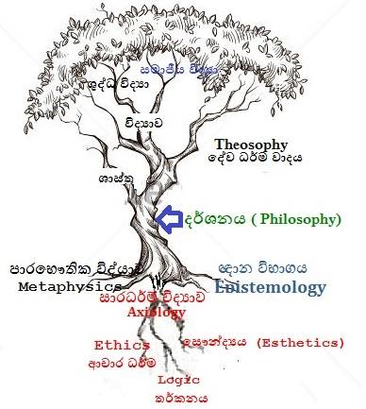
- Metaphysics: The study of being, or what really exists. All the 'ultimate stuff' questions are metaphysical ones. Meta means after or transcending.
- Epistemology: The study of belief, truth, knowledge, and rationality.
- Ethics: The study of good and evil, right and wrong, rules and virtues, character and vice, success and happiness.Ethics has lots of sub-areas, including: Business ethics: What is it okay to do? Legal ethics: Who is it okay to sue? Medical ethics: When is it okay to clone? Techno ethics: Why is it okay to tap a phone?
- Wisdom: Practical insight for living.
- Aesthetics: The study of beauty, ugliness, and maybe even the sublime. The question, What is art?, is an aesthetical one.Meta-aesthetics tip: If a theoretical aesthetician can’t match a suit and tie or a skirt and shirt, take anything they say with a grain of salt.

Language that is meaningless or is made unintelligible by excessive use of technical terms.

